**ONLINE VOTING SYSTEM**

**ACTIVITY DIAGRAM**

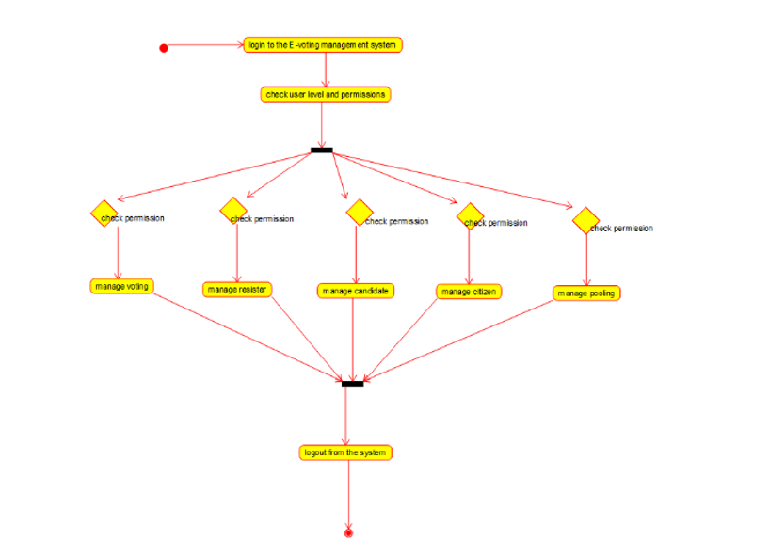

**Class diagram**

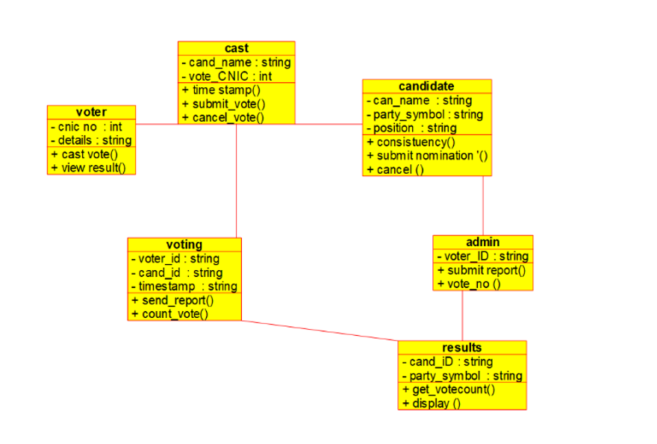

**Sequence diagram**

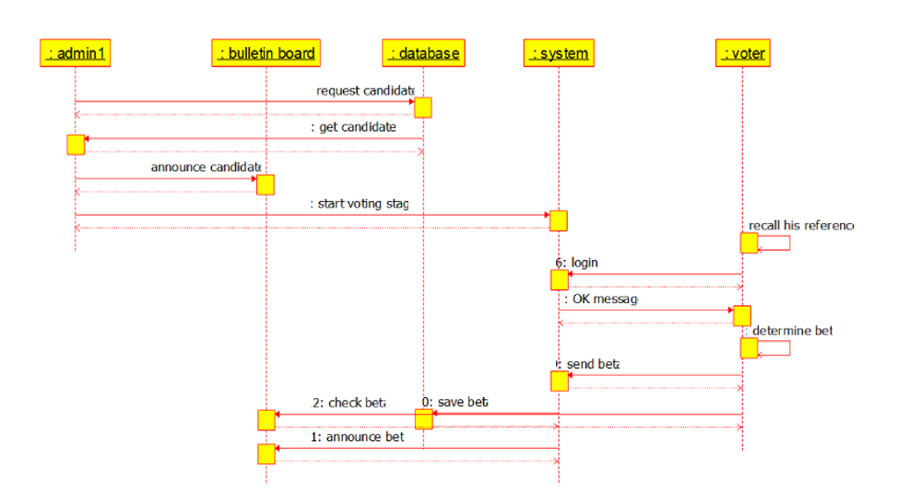

**Collaboration diagram**

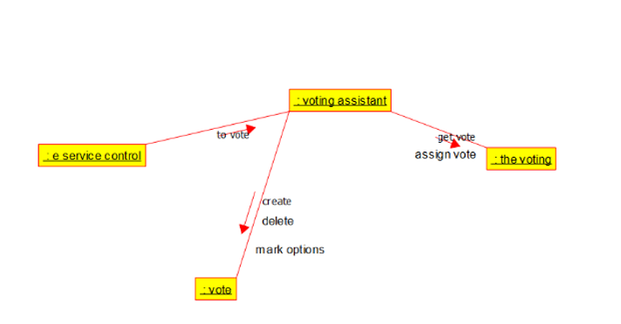

**Package diagram**

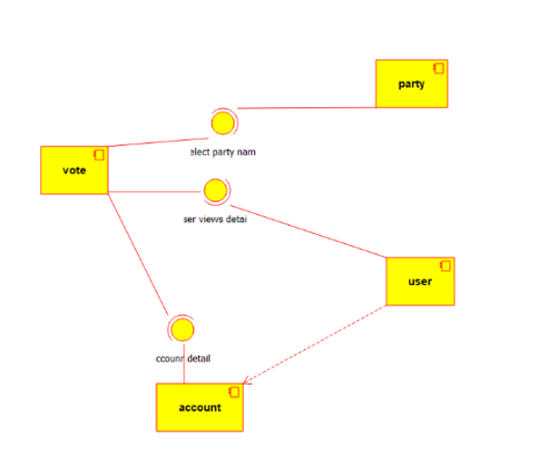

**Deployment diagram**

